**Perth Modern School**

**Semester One Examination, 2012**

**Question/Answer Booklet**

**MATHEMATICS**

Student Name _______________________

Teachers Name ______________________

Year _______________________________

**3A/3B**

**Section One:**

**Calculator-free**

|  |  |  |  |  |  |  |  |  |  |  |
| --- | --- | --- | --- | --- | --- | --- | --- | --- | --- | --- |
| Student Number: In figures |  |  |  |  |  |  |  |  |  |  |

In words

**Time allowed for this section**

Reading time before commencing work: 5 minutes

Working time for this section: 50 minutes

**Material required/recommended for this section**

***To be provided by the supervisor***

This Question/Answer Booklet

Formula Sheet

***To be provided by the candidate***

Standard items: pens, pencils, pencil sharpener, eraser, correction fluid, ruler, highlighters

Special items : nil

**Important note to candidates**

No other items may be taken into the examination room. It is **your** responsibility to ensure that you do not have any unauthorised notes or other items in the examination room. If you have any unauthorised material with you, hand it to the supervisor **before** reading any further

**Structure of this paper**

|  |  |  |  |  |  |
| --- | --- | --- | --- | --- | --- |
| Section | Number of questions available | Number of questions to be answered | Working time  (minutes) | Marks available | Percentage of exam |
| Section One  Calculator-free | 7 | 7 | 50 | 50 |  |
| Section Two  Calculator-assumed | 13 | 13 | 100 | 100 |  |

|  |  |  |
| --- | --- | --- |
| Total | 150 | 100 |

**Instructions to students**

1 Write your answers in the spaces provided in this Question/Answer Booklet. Spare pages are included at the end of this booklet. They can be used for planning your responses and/or as additional space if required to continue an answer. If you need to use the space to continue an answer, indicate in the original answer space where the answer is continued. i.e. give the page number. Fill in the number of the question(s) that you are continuing to answer at the top of the page.

2 **Show all your working clearly**. Your working should be in sufficient detail to allow your answers to be checked readily and for marks to be awarded for reasoning. Incorrect answers given without supporting reasoning cannot be allocated any marks. For any question or part question worth more than two marks, valid working or justification is required to receive full marks. If you repeat an answer to any question, ensure that you cancel the answer you do not wish to have marked.

3 It is recommended that you **do not use pencil**, except in diagrams.

**Section One: Calculator-free (50 marks)**

This section has **seven (7)** questions. Answer all questions. Write your answers in the spaces provided.

Working time: 50 minutes

_________________________________________________________________________________

**Question 1 (5 marks)**

The marks in Mr Green’s Chemistry test are normally distributed. The mean is 100 and the standard deviation is 10.

(i) Jon’s mark is 115. What is his Z-score? (1)

(ii) Christopher has a Z-score of -2. What mark did he achieve in the test? (1)

(iii) What percentage of marks lies between 80 and 110? (3)

You may assume the following:

68% of marks have Z-scores between -1 and 1

95% of marks have Z-scores between -2 and 2

99.7% of marks have Z-scores between -3 and 3

**Question 2 (8 marks)**

(a) Jonathon used the ‘capture-recapture’ technique to estimate the number of yabbies living in a dam.

* He caught, tagged and released 20 yabbies.

* Later he caught 36 yabbies at random from the same dam.

* He found that 8 of these 36 yabbies had been tagged.

Estimate the total number of yabbies living in this dam. (3)

(b) Which of the following frequency histograms shows data that could be normally distributed? (1) (A) (B)

(C) (D)

**Question 2 (continued)**

(c) Radar checks were carried out on the speed driven by drivers on two days, on a stretch of Spencer Road. The results are tabled below.

|  |  |  |  |
| --- | --- | --- | --- |
| Days | Mean | Standard deviation | Number of drivers |
| Wednesday | 60 | 10 | 100 |
| Thursday | 70 | 5 | 100 |

On which day would you expect there to be more drivers exceeding 85km/h? Explain your answer. (2)

(d) The height of students in Mrs Smith’s class range from 150cm to 175cm. Their heights were measured one day and it was found that the mean height was 160cm. Two students were absent on the day when the measurement was taken. When the heights of the absent students were included in the data, the mean height did not change. What are the possible heights of the two absent students? (2)

**Question 3 (5 marks)**

LMN is drawn with LN = 3k units, MN = (4k+1) units and LM = (3k-1) units with k>0.



(i) Which side of LMN is the longest side? (1)

(ii) If LMN is a right-angled triangle calculate the value(s) of k. (4)

**Question 4 (7 marks)**

(a) Sketch the graph of *f(x)=2(x-1)2.* Show all intercepts.(3)



(b) Indicate on the graph where you would read off the values for *x* if

4 = 2(*x*-1)2 (1)

(c) Use your graph to solve 2*x*2- 4*x* + 6 = 0. Justify your answer. (3)

**Question 5 (8 marks)**

(a) State the domain and range (in set notation) for the function y = *f(x)* drawn below. (3)



(b) Given that g*(x) = x2- x* find

1. *g*(-2) (1)
2. *g*(2x+1) (2)
3. *x* if *g(x)=*0 (2)

**Question 6 (9 marks)**

Use the laws of indices to

(a) evaluate  (2)

(b) solve the equation, showing all working steps

 (2)

**Question 6 (continued)**

(c) solve for what values of n is (3)

$\frac{6^{3n} × 9^{n+1}}{8^{n}}=1$

(d) simplify and express with positive indices. (2)

$\frac{-3a^{-2}b^{3}}{8a^{2}b^{-3}} ×\frac{-6a^{-3}b^{-4}}{-9a^{-3}b^{2}}$

**Question 7 (8 Marks)**

(a) The weight (W) in grams of individual Yoghurt Muesli Bars in a batch was measured to investigate their weight distribution.

1. Using the normal distribution curve below with mean  and standard deviation illustrate the meaning of  (1)

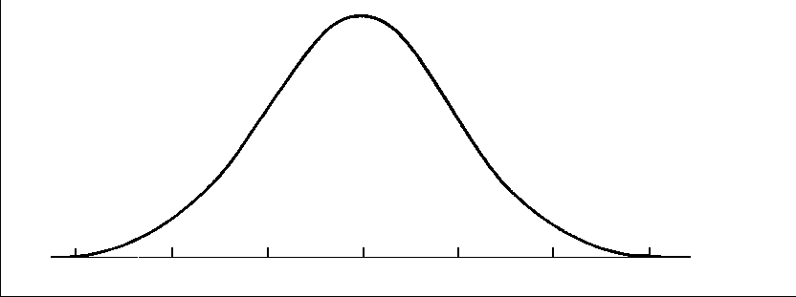

1. Using the normal distribution curve below, illustrate the meaning of

 (2)



1. The following linear equations for the mean  and the standard deviation  were determined for the distribution of the weights of individual Yoghurt Muesli Bars:



Use the equations to find the mean weight and standard deviation of Yoghurt Muesli Bars. (2)

**Question 7 (continued)**

(b) The graph of *y=f(x)* has been plotted below



On the next 3 pairs of axes A, B, C are graphs of *y=f(-x), f(x-1), -f(x)* in some order. Say which corresponds to which graph. (3)

A B





C



|  |  |
| --- | --- |
| Function | Graph |
| *y = f(-x)* |  |
| *y = f(x -1 )* |  |
| *y = -f(x)* |  |